- Best Practice -

Taking Advantage Of Getting It Right In The Camera

Don Althaus, M.A.

One of the advantages of getting the photograph as right in the camera as possible is the savings realized in the “editing workflow”. (What has become “editing” in photography is actually more adjustment and referred to as such here.) The photograph below is an original, straight-out-of-the-camera JPEG shot with an iPhone 15 Pro Max using the stock camera software.
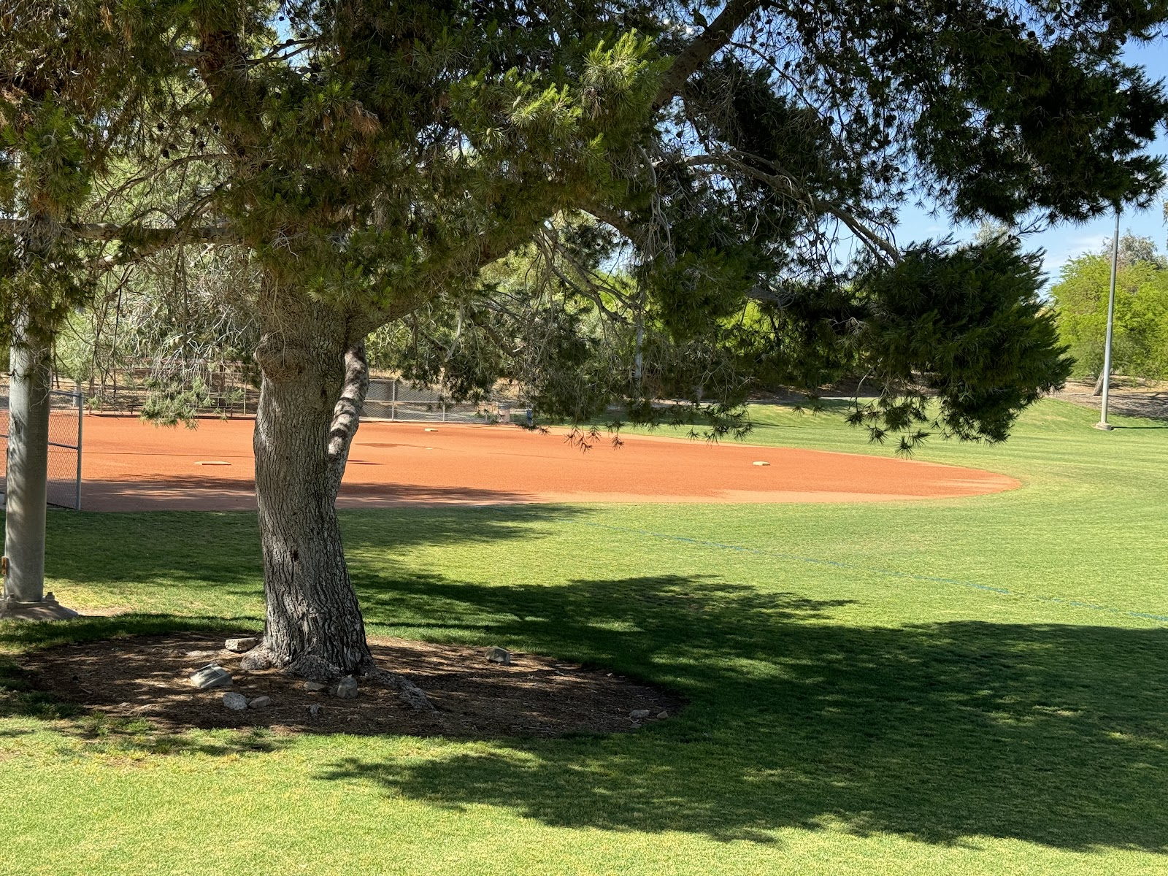
.There is a lot about the image that is as close to finished as possible except:
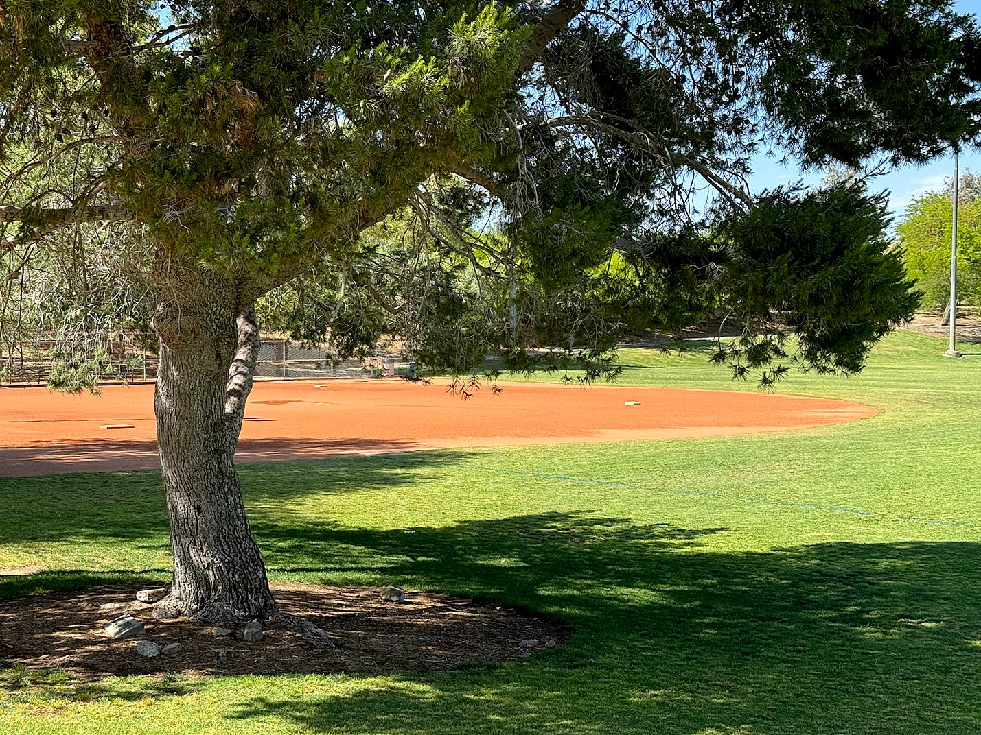
- There is a tilt to the right that needs to be corrected.
-The post in the extreme left of the frame is distracting
-Although sharpened in camera, the bark on the tree is a bit soft as is the detail in the grass.
Adjustments to this photograph are made using FastStone Image Viewer 7.9 on Windows 11.
The first issue to address is the straightening. To do this the Rotate: Straighten function is used. The photograph is straightened using the lamp stanchion which is always dead-on vertical on the extreme right of the frame. The tilt is approx 3 degrees to the left.
The next issue to be tackled is the post on the extreme left of the frame. The best way to deal with this is simply to crop the photograph slightly using the program’s Crop board with the aspect ratio set to 4:3 to maintain the original ratio. All of the removed areas will be from the left side of the frame and the bottom of the frame.
And finally a bit of straight “sharpness” was added not so much for sharpening but to add definition to the bark of the tree and the grass area.
A problem cropped up when the sharpening was added in that it bumped the contrast up a bit, intensified the colors and impacted the shadows areas. To address this bit of a change, the levels control was used to add a bit to the black point, lower the gamma a bit and lower the white point a bit.
This bit of adjustment is the kind that is typical when you make the effort to get the photograph as right as possible in the camera. Granted some photographs may require a bit more work, some may require a bit less work but it is still all minor tweaking as opposed to wholesale bludgeoning.
One more recommendation… while it’s convenient to make your adjustments on your phone or a small laptop, avoid the temptation. It is a lot more appropriate to make the adjustments on a large monitor where you can see all of the detail necessary to make the needed changes. And make sure the monitor is set to the sRGB colorspace with the standard gamma adjustment.

